Kunkuma Kodlekere

kunkumakodlekere@gmail.com

Abstract

Gmail is a powerful tool which is synonymous to email. Unique features associated with Gmail provides best user experience.

Getting familiar with Gmail

## **Table of Contents**

Introduction 1

Gmail and Business 1

Features of Gmail 1

Multiple Language support and Mail Translations 1

Search Options 2

Confidential Mode 2

Enabling Confidential mode 3

Video tutorial 3

Creating your Gmail account 4

Sending an email 5

FAQs 7

## **Introduction**

Google Mail known as Gmail is a free email service provided by Google. It’s a tool that is accessible online through a web browser or by installing Gmail application on Android or Apple devices. Users can search for specific emails and organize them according to their requirements. After you set up an account on Google explore other Google apps like Google Drive, Google Calendar. Gmail supports plugins that enables customizing workflow and themes for individuals. The Offline feature of Gmail is the need of the hour.

Gmail has made money transactions easy within Gmail accounts. An email request can be sent to receive money or send money. A google pay account is needed to send and receive money through Gmail. Currently, this money transaction feature through Gmail is available only in the US.

## **Gmail and Business**

Gmail is SaaS (Software as a service) cloud computing service. Google hosts the email server and browser access is provided. Gmail provides paid professional email service G suite. A Gmail account with the company’s domain name becomes ad-free. A professional domain name Gmail builds customer trust. Businesses can benefit from unlimited Gmail, drive storage, and 24*7 Support.

## **Features of Gmail**

### **1. Multiple Language support and Mail Translations**

Gmail has made it easy to communicate with people of different languages. Gmail allows you to compose emails in 105 languages using native keyboards and input tools. **Right to left editing** support is enabled in Settings for composing emails in languages like Arabic or Persian. The process of updating Gmail inbox to read messages in preferred language differs depending on the device. If Gmail discovers a mail that is not in your default language a translation bar is provided that is accessed by icon of that particular mail. Using Transliteration, type phonetically in English and words will be replaced by their correct letters of the language.

***Note****:* In this tutorial, all processes and steps are explained for computer devices only.

#### **Enabling input tools**

1. Settings **See all settings** General tab Language Click on **Show all language options,** **Enable input tools** is visible.
2. Select **Enable input tools** A pop-up window appearsto choose languages Scroll down the pop-up and click **Save Changes.**
3. Once you have Enabled Input Tools, Compose emails in different languages by new drop –down  on the top right with the one or two letters of your language. Click on it to select your language and input type.

### **2. Search Options**

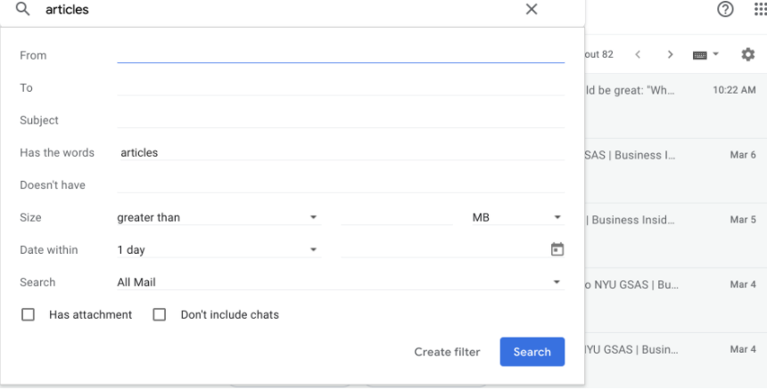Searching a specific email from your inbox is sometimes a hassle. Gmail has made search faster by providing specific search terms, automatic search terms are provided which includes typed words or phrases. Select one or more search options to find the mail. The **Advanced Search option** is used to fine-tune the search process. Few search terms are from, when, Has attachment, Date, All Mail.

### **3. Confidential Mode**

Confidential mode of Gmail is a way of making emails more private. An expiration date is added to emails. Confidential emails cannot be copied, forwarded, printed, or downloaded. This mode requires a verification code to open the mail.

***Note****:* Taking screenshots and photos of the mail is possible.

Confidential Mode is more private but not secure.

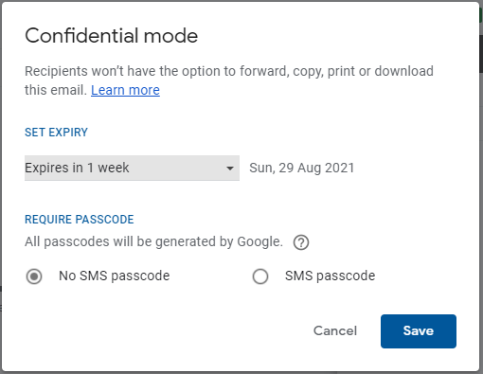

### **Enabling Confidential mode**

1. Click Compose in Gmail.
2. Click **Turn on confidential mode** at the bottom right of the window.
3. **Set Expiry** bychoosing from the drop-down menu provided.
4. Select **SMS passcode** radio button (round button). Recipients of the confidential mail receive passcode by text message.
5. Click **Save**.

## **Video tutorial**

In this video, three lesser-known features of Gmail are explained.



***Note:*** Use the link <https://youtu.be/VisYSbWtsZc> to access the video if you are not able to see the online video that is provided.

## **Creating your Gmail account**

Creating a Gmail account is a simple procedure. Gmail accounts are a requirement widely in today’s world. Few Android devices have made mandatory Gmail address log in to use the device.

Follow these simple steps to create a Gmail account.

1. Go to Google account sign-in page <http://accounts.google.com/signup>
2. Enter First name, Last name, and a Username.

***Note*:** If the entered Username is unavailable an error message is seen on the screen. Enter a different Username which should be unique.

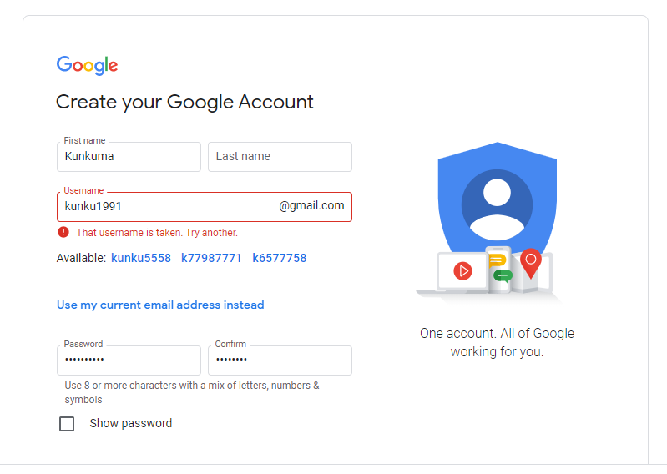

3. Enter a secure password with 8 or more characters; enter the password again in the space provided below Confirm.

4. Click **Next.**

5. Enter your Mobile number to verify your account.

6. Google sends a 6-digit verification code by text message.

7. Click **Next**.

***Note***: This was an optional step but Google has recently made this step mandatory. A landline number is also permitted for verification. Google uses the voice call option in this case.

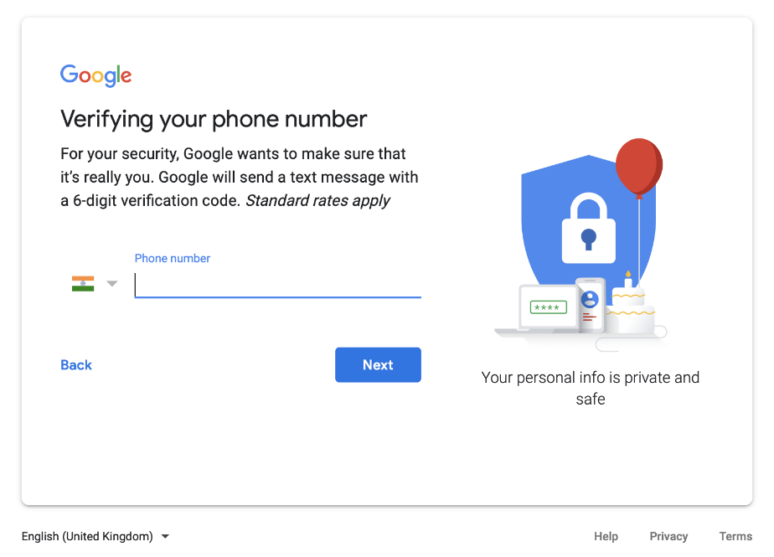

## **Sending an email**

1. Before sending an email Click **Compose** buttonin the left menu.

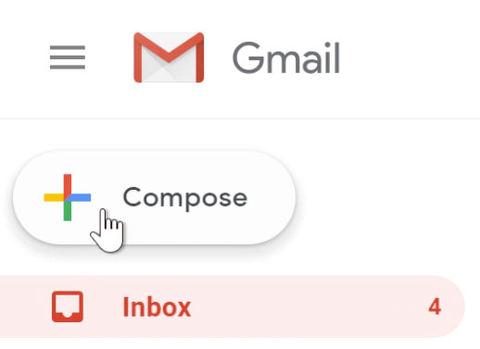

2. In the new compose window enter one or more recipients in the space provided for **To**. Separate the recipients by adding commas in between mail addresses or by choosing email addresses from the contacts list.

***Note:*** Add few recipients in **Cc** (Carbon copy) and **Bcc** (Blind Carbon Copy).Recipients are in Cc if you want everyone to see and recipients are in Bcc if you don’t want others to see.

3. Enter **Subject** of your mail. Though this field (space) can be left empty, it is a best practice to add Subject to your emails.

4. Type your message.

5. Add an attachment if required – Word, PDF, JPEG or PNG, and other supported file formats.

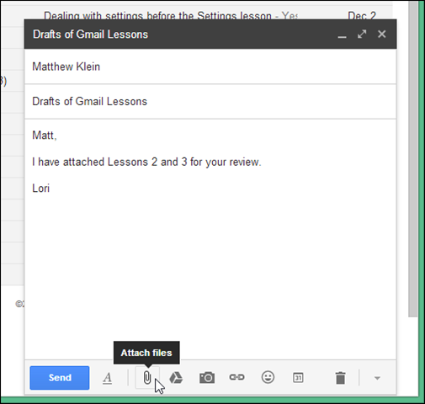

6. Various formatting options are provided at the bottom of compose window which include text formatting options like Bold, Italics, different font options, changing font colours, and many more.

7. An email signature is added as follows.

1. **Settings See all settings General tab Signature**

1. Add your Signature by **Create new**. Format and change the style by adding images, logos, and text style.
2. Click **Save Changes.**

***Note:*** Multiple signatures are supported.

8. Click **Send.**

## **FAQs**

**1.What is Archive in Gmail?**

The Archive feature moves the email from **Inbox** view to **All Mail** view**.** Emails that are archived are not deleted. The Archive feature ensures that emails are stored separately in a folder and decreases the risk of losing the mail.

**2.Do Gmail accounts expire?**

Gmail accounts do not expire if an account is not in use for a brief period. But if an account is inactive for a period of more than 24 months you may lose data like images, videos documents. It is advisable to keep logging in once in a while.

**3.How to make Gmail my default email program from Chrome Browser?**

1. Open Chrome Browser and Click on  at the top right corner of the browser.
2. Go to **Settings** **Privacy and security Site Settings**
3. Scroll downto **Additional permissions** and click 
4. Click **Handlers**
5. Select the radio button (round button) option **Sites can ask to handle protocols.**

***Note*:** In **Site Settings Pop-ups and redirects** ensure mail.google.com is not under the blocked list.

1. In chrome’s address bar enter mail.google.com.
2. Click **Service Handler** and Allow Done

**4.How much storage does Gmail provide? What is the maximum file size permitted for attachments?**

Google provides 7 GB of free storage space on Gmail. Gmail provides a maximum file attachment capacity of 20 MB above which Google drive must be used for file sharing.

**5.Is it possible to delete particular mail from a conversation?**

Yes, it is possible.

1. Open the mail conversation and Click at the right corner.
2. Select **Delete this message**

**6.Is it Possible to send scheduled emails in Gmail?**

Yes, it is possible.

1. After you have composed a mail and added a recipient click on  next to **Send** button.
2. Choose **Schedule Send.**
3. Choose the given optionsor **Select Date and time**

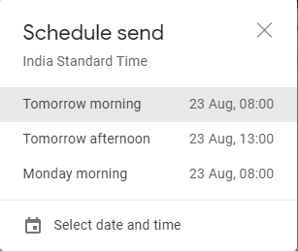

**7.How long do emails stay in the trash?**

Emails stay for a fixed period of 30 days in trash and spam. After this period Gmail permanently deletes it.

**8.How to use multiple Gmail accounts?**

Signing in to multiple accounts and toggling between both is possible.

1. On the computer sign in to your existing account.
2. Select your profile image at the top right.
3. Add account or select the account you want to use.

**9.Is it possible to use Gmail offline?**

Yes, Gmail allows search, read, label, and delete options if you don’t have internet. Responding to an email without the internet is possible; these emails will be queued and when your computer connects to the internet all the activities will be synced.

**10. How to enable offline Gmail?**

Gmail offline is available only for chrome browsers.

* 1. Click on **Settings** in the top right corner.
  2. Select **See all settings** Select **Offline** tab Select the checkbox (Square box) **Enable offline mail.**
  3. **Sync Settings** Choose how long you want Gmail to store emails offline and Select **Download attachments** checkbox (square box) if you want to download attachments.
  4. **Security**  Select **Keep offline data on my computer** or **Remove offline data from my computer** when you sign out of Gmail Click **Save Changes**.

**11**. **Are Gmail addresses case sensitive?**

No, they are case insensitive. If you intend to send a mail to [abc@hiscompany.com](mailto:abc@hiscompany.com) and you send it to [Abc@hISCompany.com](mailto:Abc@hISCompany.com) Gmail has got your back! It ignores the case.